Managing Specifications in the Specific Architecture (SpA)
Purpose: This guideline outlines how legal, technical, and advisory specifications are curated, classified, stored, and maintained within the SPA model in Enterprise Architect (EA). Specifications form a traceable knowledge base and serve as sources for modelled Requirements that connect to SpA components.
Audience: SPA maintenance team.
Version | Author | Note
1.0 | Petr Bureš | Revised, simplified structure of the Specification, added requirements connection.
1.1 | Petr Bure3 | Reworked from NAP reference architecture specifics to a Generic Specific Architecture

Scope
This guideline covers:
- All Specification objects maintained in EA
- Structure, classification and linkage
- Excludes:
  - Specifications derived from KPIs (see Guideline 2)
  - Requirements derived from Specifications (see Guideline 3)

Role of Specifications in the SPA
Specifications are modelled to represent formal, external documents (legal acts, standards, guidance) relevant to the SpA. These are high-level sources and are not directly linked to architecture objects. Instead, Requirements are derived from them to establish traceable constraints and obligations in the model.
> Specification → Requirement → SpA Object This layered linkage supports flexibility, traceability, and clarity.
- A single Specification may yield multiple Requirements
- Some Specifications may yield no Requirements if not applicable to the architecture

Specification Folder Structure
Specifications are maintained in: Supplements\Specifications and Recommendations
Subfolders represent specification categories:
- Legal – EU directives, regulations, implementing acts
- Technical – e.g., DATEX II, NETEX, SIRI
- Recommendation – guidance, industry good practices
- Profiles – Data model profiles
- Superseded – Deprecated specs with trace links retained
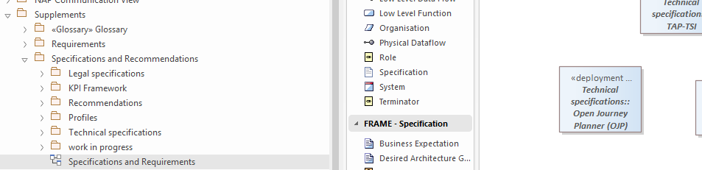

Modelling Specifications in the SPA

Specification Content
Following structure describe and document specifications:
- Short Name Concise title used in diagrams, lists, or references. Typically, an abbreviation or a commonly recognized term.
- Full Name Official, unabbreviated name of the specification.
- Link URL linking directly to the official source document or specification repository.
- Type Classification of the specification, selected from the following: Legal, Technical, Recommendation, Profile, KPI.
- Description A brief summary of the specification’s purpose and scope. If the specification supersedes a previous version, highlight the key changes or improvements.
- Additional Context Explanation of the specification’s relevance within the system landscape (e.g. its role in the SpA ecosystem). Include noteworthy attributes, constraints, or expected benefits that are valuable for implementers or stakeholders.
- Related Resources A curated list of associated documents that further explain, support, or operationalize the specification. May include:
  - Delegated regulations and legislative texts
  - Parts or modules of the standard
  - Implementation guidelines and manuals
  - Evaluation or summary reports
  - Informative web articles and official portals
  - Schema repositories, technical tools, or open-source software
- Each ‘Related Resources’ entry should include:
  - Short name (hyperlinked if available)
  - Brief description outlining the document’s role or content

Naming Convention
Specification names follow this format:
- Prefix: L (Legal), S (Standard), R (Recommendation), KPI, P (Profile)
- Document number or version: e.g. L1, S_CEN14589
- Descriptive label: e.g. "ITS Directive" or "Traffic Info Standard"
Example: L8 Directive (EU) 2023/2661 - ITS (recast)
Important rule: Assigning the prefix and number (e.g. L1, KPI 1.3) is important ONLY for the identification of Requirements, the naming convention of requirements rely on these prefixes. So the numbering is arbitrary and does not carry any meaning.

Compaction Rule
Model only one Specification object per series or legislative act, regardless of the number of parts. For instance, the DATEX II suite is represented by a single object.

Linking & Hierarchy
Specifications are arranged in this hierarchy (when applicable):
- Directive → Delegated Regulation → Standard → Profile
Connectors:
- Realization: from Regulation to its Directive
- Usage: from Standard to the Regulation it implements
- Usage: from Profile to the Standard, it extends
- Substitution: from new Specification to repealed Specification
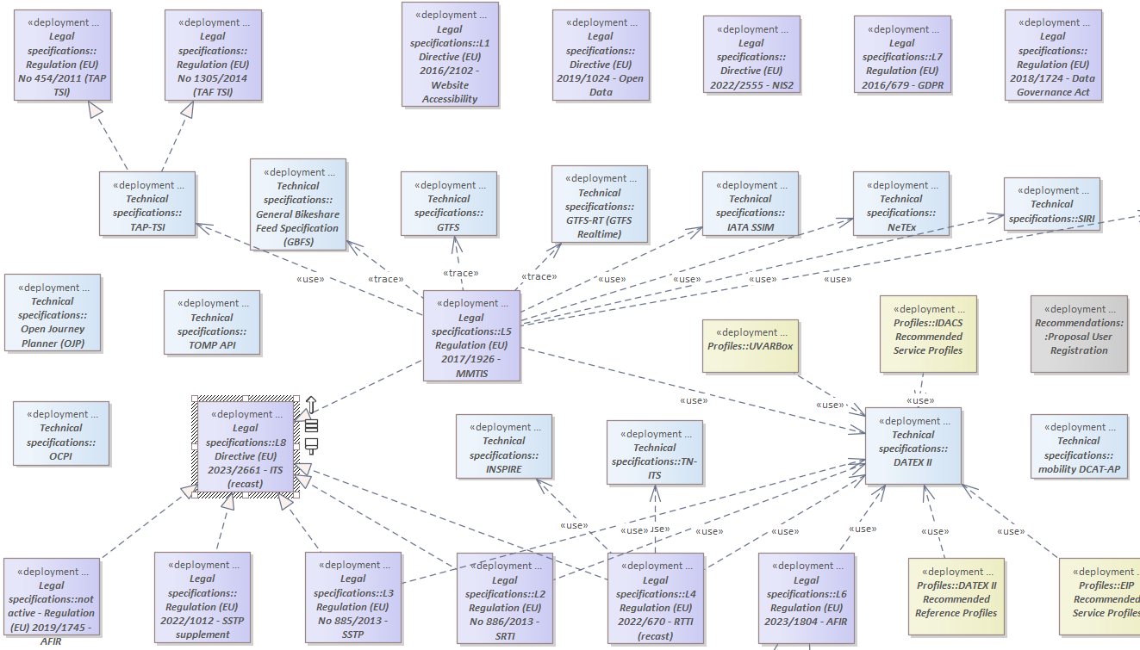
> Direct connections to SpA architecture objects are not used—those are managed via Requirements (see Guideline 3)

Working with Requirements
Some Specifications result in Requirements that articulate enforceable architectural constraints. See the Requirement guideline for:
- Creating Requirements
- Moving requirement in the model
- Mapping and Linking Requirements to SPA Objects
Important rule: If the Specification does not yield any Requirement, then it shall be linked to a global issue “Does not yield a Requirement”.

Specification Maintenance and Updates

Trigger
Initiated during major updates, or when external specifications are revised.

Version Tracking
Specifications themselves are not versioned. Use related metadata or document references for version awareness.

Update Procedure
This procedure outlines how to maintain the specification registry when changes occur, ensuring all links and dependencies remain accurate and up to date.
📌 When an Existing Specification Is Updated
- Review the content of the updated specification.
- Update the metadata and description fields to reflect the changes.
- Verify all linked Requirements and Issues:
  - Revise or retire Requirements that are no longer valid.
  - Remap or unmap impacted SPA components accordingly.
🗂 When a Specification Is Deprecated
- Move the deprecated specification to the Superseded folder.
- Relink downstream Requirements and SPA mappings to the replacement Specification.
  - If no direct replacement exists:
    - Assess each Requirement and mapping:
      - Can it be mapped to a different specification?
      - Is it now redundant due to other existing Requirements?
      - If not, create an empty placeholder object titled “Generic Specification” and map the Requirement there.
- Create a trace link to any Specification that supersedes or replaces the deprecated one.
➕ When a New Specification Becomes Relevant
- Add the Specification to the appropriate domain-specific subfolder.
- Apply modeling rules outlined in Sections 4–5.
- Derive and link Requirements based on the Specification’s content and scope.

Specification examples
This structure ensures that each specification is clearly identified, classified, and described, making it easier to reference and understand its context and use.

Legal specification

RTTI Delegated regulation
Short name: Regulation (EU) 2015/962 - RTTI
Type: Legal
Full Name: Commission Delegated Regulation (EU) 2015/962 of 18 December 2014 supplementing Directive 2010/40/EU with regard to the provision of EU-wide real-time traffic information services
Link: https://eur-lex.europa.eu/eli/reg_del/2015/962/oj
Description: This regulation defined the initial technical specifications for the provision of EU-wide real-time traffic information (RTTI) services under Directive 2010/40/EU. It established requirements for the availability, accessibility, exchange, and re-use of static and dynamic road traffic data. It introduced the concept of a minimum level of service and required Member States to designate National Access Points (NAPs) for data publication. The regulation was repealed with effect from 31 December 2024 and replaced by Regulation (EU) 2022/670, which introduced updated data categories, performance requirements, and alignment with current ITS deployment practices.
Additional details: NAPs were required to provide machine-readable access to RTTI-relevant datasets, including road network attributes, traffic regulations, and real-time traffic status. The regulation mandated metadata publication, data quality assurance, and use of harmonised formats to support cross-border interoperability. It served as the legal foundation for early RTTI deployments and was superseded to reflect evolving data models and service expectations.
Related Documents:
- Regulation (EU) 2022/670 – Successor regulation introducing revised RTTI specifications.
- European Commission RTTI Guidance – Implementation context and technical interpretation.
- DATEX II Reference Profile for RTTI – Defines the harmonised data model for compliant RTTI data exchange.
- NAPCORE RTTI Workstream Summary (PDF) – Overview of Member State alignment and implementation under the updated regulation.

Technical standards

GBFS
Short name: General Bikeshare Feed Specification (GBFS)
Type: Technical Standard
Full Name: General Bikeshare Feed Specification (GBFS)
Link: https://www.gbfs.org/
Description: GBFS is an open, real-time data standard for shared mobility systems (e.g. bikeshare, scooters, mopeds). It defines a uniform JSON-based structure for publishing system status, vehicle availability, pricing, and station metadata. GBFS is designed for public consumption by trip planners, mobility apps, and data aggregators. It is read-only and does not support transactional operations.
Additional details: -
Related Documents:
- GBFS GitHub Repository – Specification source, schemas, governance model.
- GBFS v3.0 Specification – Latest stable version with feed definitions and field requirements.
- GBFS Validator Tool – Online tool for schema validation and feed diagnostics.
- GBFS Systems Catalog – List of known GBFS-compliant deployments.
- GBFS website: GBFS specification web site

Recommendations

MQA Methodology
Short name: MQA Metadata Quality Assessment Methodology
Type: Recommendation
Full Name: Metadata Quality Assessment Methodology.
Link: https://data.europa.eu/mqa/methodology?locale=en
Description The Metadata Quality Assessment (MQA) is a tool developed by the consortium of data.europa.eu to study the quality of metadata harvested by data.europa.eu. It is intended to help data providers and data portals to check their metadata quality and to receive suggestions for improvements. The results are presented via the MQA and are also available as download. In the following we describe the functionality of the MQA and the methodology it uses.
Additional details: The NAPs are encouraged to follow this methodology since it would allow better interoperability between NAPs. There is also SHACL validator available https://data.europa.eu/mqa/shacl-validator-ui/data-provision. Norwegian NAP has implemented this methodology, see https://transportportal.no/ in any of the catalogue records.
Related Documents: -

Open Questions
- How to connect Recommendation Specifications to the SPA Objects?
- How to connect Technical Specifications to the SPA Objects?

Annex
